12 PM Pacific/1 PM Mountain/2 PM Central/3 PM Eastern – 1 Hour Webinars (FREE)

This year's theme is "Pipeline to Promotion" and will focus on the spectrum of staff development related to hiring through succession planning, giving thought to motivations of potential employees as well as current employees.

Who should participate in Virtual Summer School?
Anyone!
From Extension directors to mid-managers, to program and staff development specialists and beyond -- we welcome anyone with an interest in these topics to join us for any or all of the sessions.
Register for any of following sessions using the session’s Zoom link listed below.

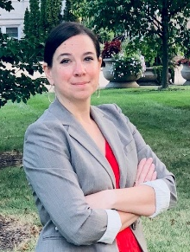
Monday, July 11th
Starting on the Right Foot: Recruiting and Hiring
Speaker:
Kim LeCompte, Ph.D., SHRM-CP, Senior Human Resources Consultant, University of Missouri-Columbia

Link to Register: https://uada.zoom.us/webinar/register/WN_U_JFLDDkT9uqGDiROcC7WA#/registration

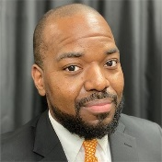
Tuesday, July 12th
Focus on Diversity from New Hire to Succession Planning

Speakers:
John Toman, Ph.D., Interim Director, Extension Evaluation & Staff Development, University of Tennessee Institute of Agriculture
Craig Pickett, Jr., Ph.D., Director for Diversity, Equity and Inclusion, University of Tennessee Institute of Agriculture
Matthew Kaplan, Ph.D., Professor, Intergenerational Programs and Aging, Penn State University

Link to Register: https://uada.zoom.us/webinar/register/WN_8AHFtqCqT8K-tuokLD6kMA
Wednesday, July 13th
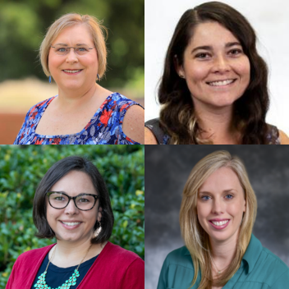
Onboarding for Today's Extension: Panel Discussion

Panel Facilitator: Cheryl Newberry, M.S., Program and Personnel Development Specialist, Oklahoma State University Extension
Panelists:
Amanda Rysz, M.S., Family and Consumer Sciences Program Specialist-Training and Professional Development, Ohio State Extension
Kristi Farner, Ph.D., Staff and Organizational Development Specialist, UGA Extension
Tearney Woodruff, Ph.D., Extension Specialist- Employee Development & Continuous Learning, Texas A&M University AgriLife

Link to Register: https://uada.zoom.us/webinar/register/WN_xiH_WnqERuySvYQp_5g6kw

Thursday, July 14th
Strengthen Extension's Employees through Capacity Building

Speakers:
Crystal Tyler-Mackey, Ph.D., Extension Leader for Inclusion and Diversity, Virginia Cooperative Extension
Karl Bradley, Leadership Development Specialist, Extension Foundation

Link to Register: https://uada.zoom.us/webinar/register/WN_7c886_8iRoORAPHjNduVvA

Friday, July 15th
Building Tomorrow's Extension Leaders

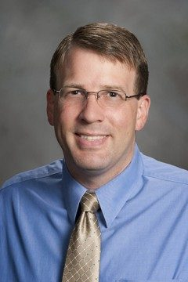
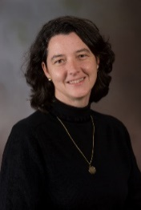
Speakers:
Rochelle Sapp, Ph.D., Leadership Development Specialist, UGA Extension
Sarah Baughman, Ph.D., Extension Leader for Program and Employee Development, Virginia Cooperative Extension
Eric Kaufman, Ph.D., Leadership Development, Virginia Cooperative Extension

Link to Register: https://uada.zoom.us/webinar/register/WN_FqXkn3RZQ_KuOcJZhWenng

To view all session information and registration links, visit the following web page:
https://naepsdp.org/Upcoming-Webinars
All session recordings will be housed on the NAEPSDP Webinar Archives Page at: https://naepsdp.org/Webinar-Archive

