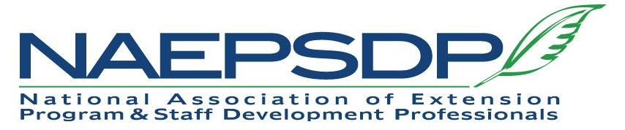

TO: NAEPSDP Members
DT: October 15, 2021

This communication to NAEPSDP, posted at least 30 days prior to the start of the annual meeting, serves as the announcement of changes requiring action by the membership.
The Board has approved changes to the Constitution and Bylaws. Now it is your turn.
At the Business Meeting on 12/2 during the 2021 Virtual Conference, NAEPSDP members will have the opportunity to review, discuss, and approve changes to the Constitution and Bylaws.
The Constitution and Bylaws edits address:
- the definition of a member “in good standing” for consistency across organization activities (board membership, eligibility and nominations for awards and elected positions, and voting),
- updating the use of pronouns, and
- the expansion of suggested annual timeline activities.
The document provided shows edits to the Constitution and Bylaws. Please review in preparation for the Business Meeting on 12/2.
Please let me know if you have any questions. I look forward to seeing you in December.

Julie Huetteman
NAEPSDP President-Elect

